RSA MFA Agent Installation

Please follow these directions closely. This installation is mandated by the Blue Cross/Blue Shield Association. It must be completed before the Christmas holiday. **It is imperative that you follow these directions, as the next level of support requires physically going into the iTec for assistance.**

Step 1 – Make sure you have the icon below on your phone. It must also have been registered as part of a separate process. Be sure that your laptop is connected to VPN for steps in this document.

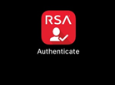

Step 2- The software will be deployed automatically to your workstation. To verify it is installed, click the start button and type RSA. You should see something like the image below. Open RSA MFA Agent Test Authentication.

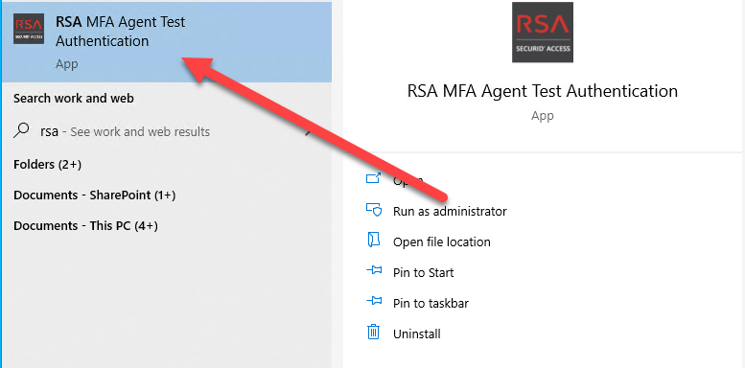

Step 3 – In the Username field enter **your entire email address**. In the image below I have used mine for reference. After your email address is entered the button to Test Online Authentication will be clickable. Click the button.

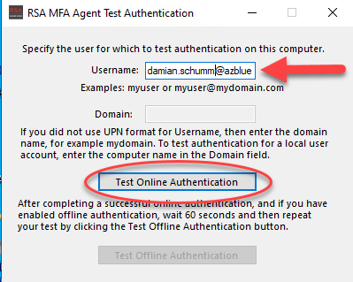

Step 4 – The screen below should appear after a moment. You do not need to click anything at this point. The system should send a push notification to your registered RDA Authenticate device. On your registered device, click the green check to complete the test. **Note: If you see the screen on the next page instead of the one directly below this, skip to step 4b below.** Otherwise continue to step 5.

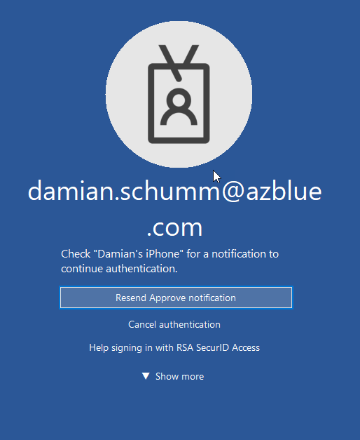 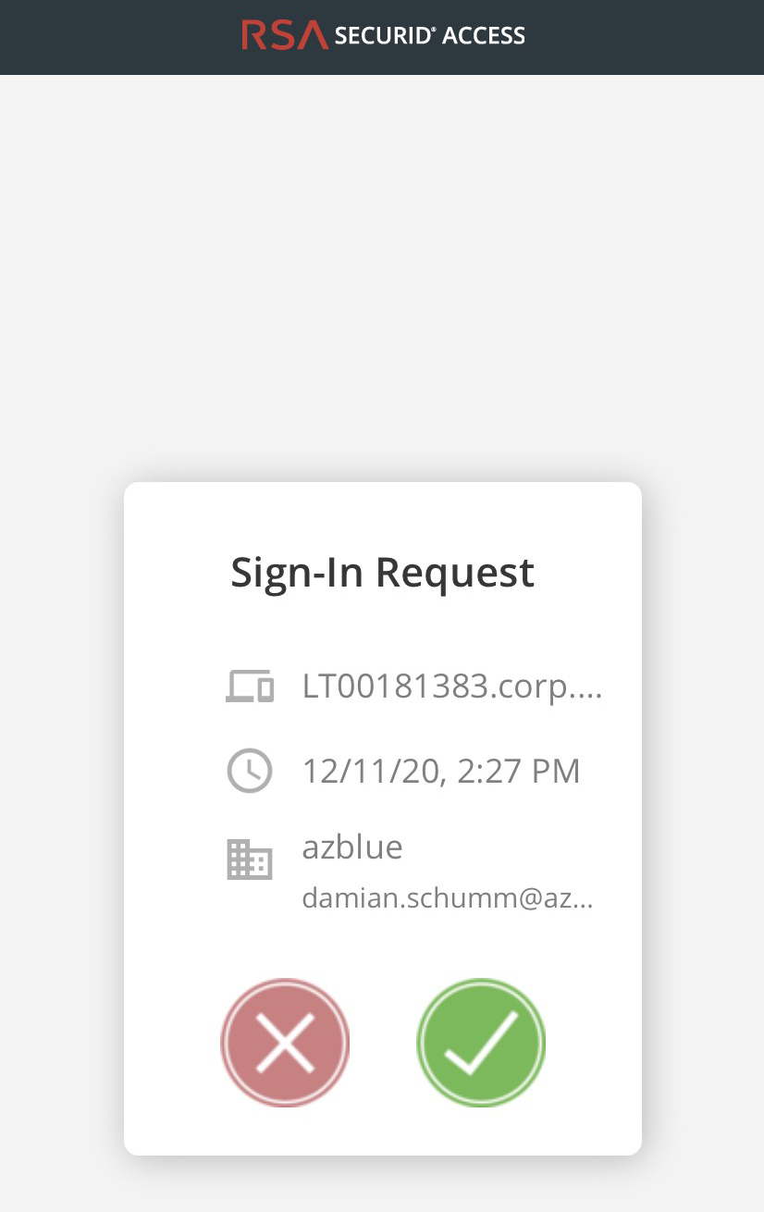

Step 4b – If you see a line to enter Authenticate Tokencode (shown below) click the down arrow next to Show More and then select the button labeled RSA with the check in the circle as indicated by the red arrow in the image on the right below then go back to Step 4.

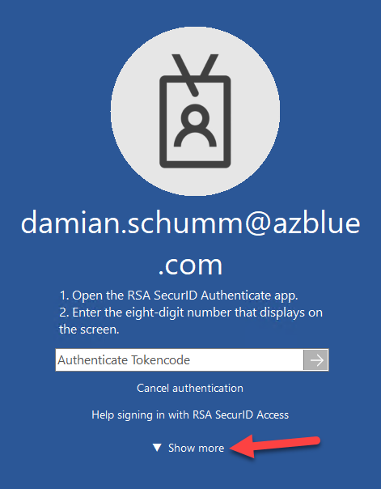 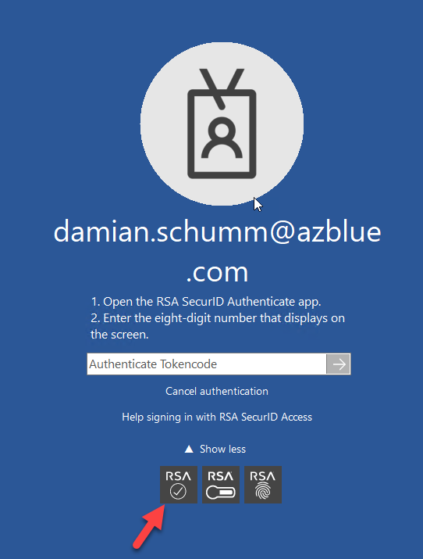

Step 5 – Click OK on the screen below.

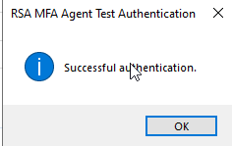

Step 6 – After a moment, the Test Offline Authentication button should light up. Click it.

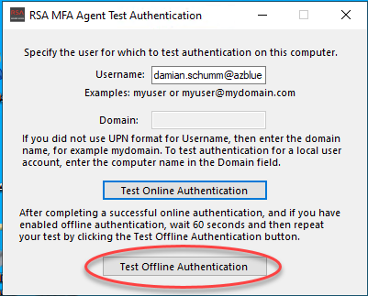

Step 7 – The screen below will be displayed. Use the RSA Authenticate app to generate a tokencode as shown in the second image below.

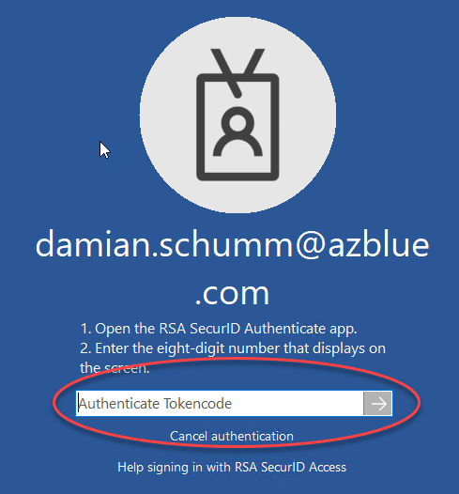 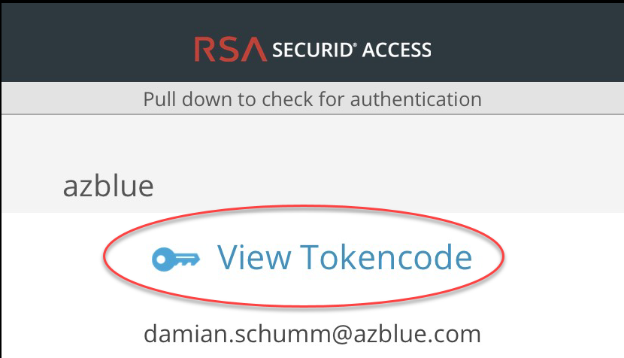

Step 8 – Click OK to complete the test.



Step 9 – Lock your laptop. You will be presented with the screen below. Enter your normal login password.

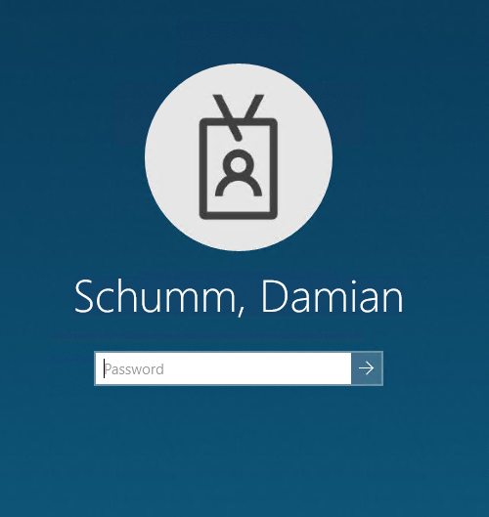

Step 10 – At this point you should receive a push notification to your phone. Click the green check mark to complete this process and this document.